**Example of Ministry of Children and Youth Copy**

<http://www.children.gov.on.ca/htdocs/English/professionals/steppingup/index.aspx>

<http://www.children.gov.on.ca/htdocs/English/professionals/steppingstones/youth_policy.aspx>

**Example Visualization - Gears are Central To This Work...**

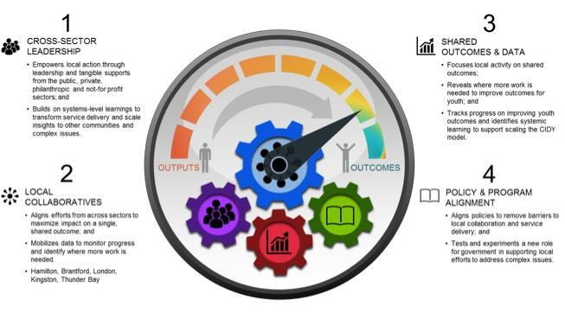

**Example Mature Initiatives**

<http://innoweave.ca/en/modules/collective-impact/youth-ci>

<http://youthrex.com/>

<http://www.strivepartnership.org/>

<http://www.roadmapproject.org/>

<http://calgaryhomeless.com/>

We also need a BETTER way of referring to young people that we want to focus our efforts on.

Currently, the gove